**Figure 1**

**Analysis**

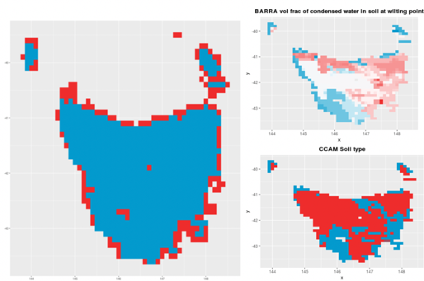

Figure 1: *The left is differences in the spatial coverage between CCAM-ensemble and BARRA-TA. Blue is the 10 km-resolution CCAM-ensemble grid and in red indicates the area where the 1.5km0resolution BARRA-TA grid downscaled to 10 km-resolution extends beyond the CCAM-ensemble coverage. The right top one is one of the soil parameters (Volume fraction of condensed water in soil at critical point) in BARRA-TA. The right bottom one is two soil types in CCAM.*

**Methods**

**Outcome**

**Comment**

This says wrong thing. 1. It is inaccuracy to compare soil type with soil parameters; 2. CCAM’s soil parameter is more than 3 (from Marcus’s comment)

**Figure 2 & 3**

**Analysis**

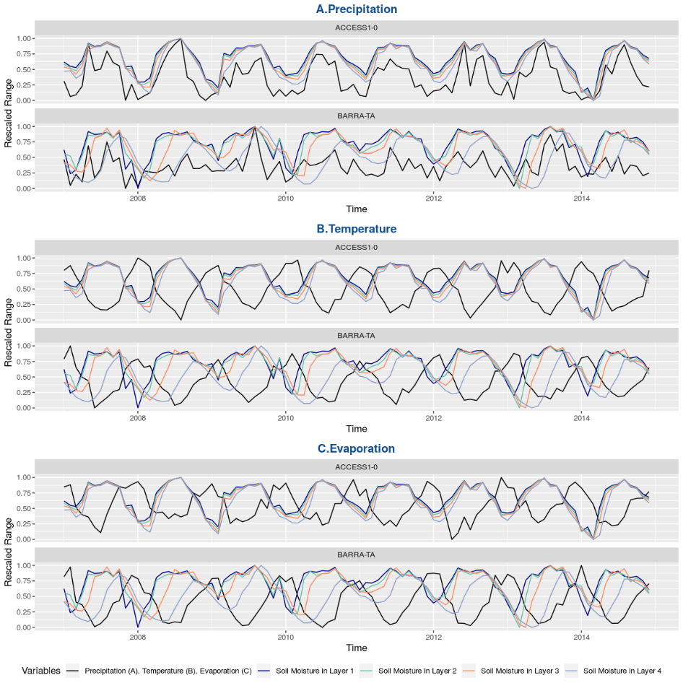

Figure 2 *An example monthly time-series for west Tasmania representing the percentage if change in the monthly mean of soil moisture compared to temperature, precipitation and evaporation for both ACCESS1-0 and BARRA-TA. (Values have been rescaled to a common scale for comparison).*

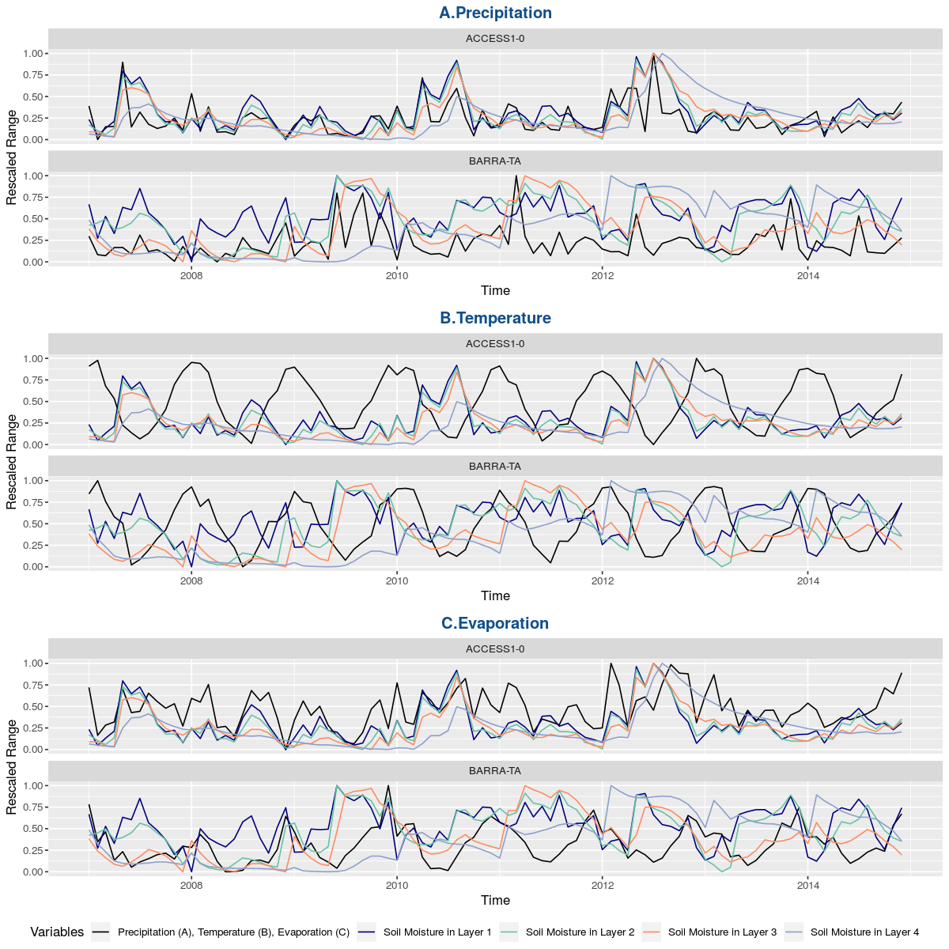

Figure 3 *An example monthly time-series for east Tasmania representing the percentage of change in the monthly mean of soil moisture compared to temperature, precipitation and evaporation for both ACCESS1-0 and BARRA-TA. (Values have been rescaled to a common scale for comparison).*

**Methods**

Considering the different topography and precipitation in west and east Tasmania, we took one point in each of these regions and compared the monthly time-series over 8 years (2007-2014) between ACCESS-G - one of the CCAM RCMs as an example - and BARRA-TA over soil moisture and related variables. The reason for ACCESS-G is that we found one model’s extreme values were averaged out by the other five models in the ensemble mean. Because of the different unit and magnitude between the variables we considered, for visualizing the change we had to rescale the variation.

**Outcome**

We first investigated the monthly variation of soil moisture with its monthly mean value at two grid cells, one in west Tasmania (Figure 2) and one in east Tasmania (Figure 3) over the common period (2007-2014). The high correlation area in the west means that the west grid cell can be representative for the cells around it and it can be used to explore the relationship between soil moisture and a range of variables. The east grid cell is in a low correlation area and it could show a time-series different from the western area.

In the west grid cell, the time-series of monthly soil moisture is very similar in all four layers of ACCESS1-0, all showing a strong correlation (or anticorrelation) with precipitation, temperature and evaporation (Figure 2). In BARRA-TA however, there is an obvious lag between the different soil layers, which increases with depth. This lag of more than one month, lead to low correlation of the soil moisture in the bottom layers with surface conditions. Comparing ACCESS1-0 with BARRA-TA, we find that the annual cycle is more obvious in ACCESS1-0 and more intra-annual change is represented in the later. The lag in ACCESS1-0 is small, and is more variable with the lower values of soil moisture. The fluctuation in temperature had less amplitude than other values, which could translate into higher correlation values by least square regression.

With low evaporation in the east grid cell, the time-series of soil moisture in the top layer 1 fluctuated more than in the other three soil layers (Figure 3). Layers 2 to 4 showed lower values and less correlation in the soil moisture and the three related variables compared to layer 1. Analyzing the precipitation and soil moisture in the four layers, there were more random changes with lower precipitation values than in west region, and the change was dominated by extreme precipitation values each time. In the analysis of each CCAM ensemble member and the CCAM-ensemble mean, we found that one model’s extreme values were averaged out by the other five models.

**Discussion**

In the spatial correlation of soil moisture between CCAM-ensemble and BARRA-TA, we found the correlation values of soil moisture are higher in the west and north of Tasmania. The topography of south-east Tasmania is mostly lowland, resulting in mostly dry area with lower annual precipitation than the north and west mountainous region (Grose et al. 2010; White et al. 2013). In dry areas, the change of soil moisture is more closely related to episodic precipitation. But in wet areas, soil moisture will dry out or filtrate slowly over time, which can be easier to simulate in both models. Hence in dry areas, the timing of simulated precipitation is crucial for an accurate modelled output of soil moisture.

**Comment**

You should explain why choose these two grid cells within all grid cells.

I think these two figures could make reader confused and should be deleted. (or is there better way to present it?)

Detail: Why confused?

Because it needs to explain how we ensure the location of the two grid cells, and why just take one grid cells at each west and east region, as well as how we judge the boundary between west region and east region.

Also, we only consider ACCESS1-0 model in CCAM. Should it be explained why we take the ACCESS1-0 as example?

**Figure 4 & 5**

**Analysis**

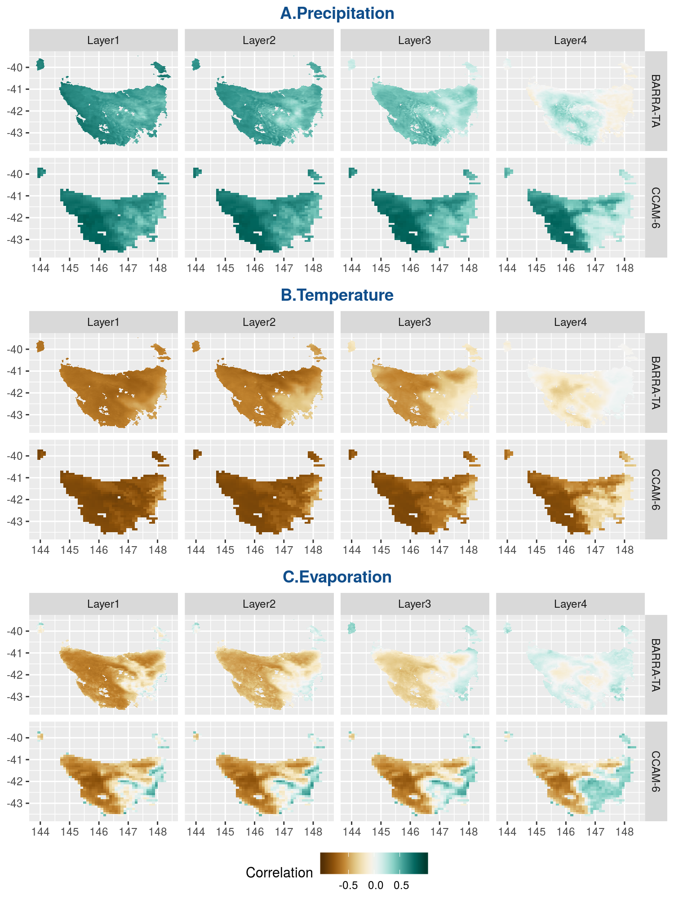

Figure 4 *The correlation between soil moisture and a range of variables in CCAM-ensemble from the multi-year monthly mean value over all grid cells in Tasmania, in comparison with BARRA-TA. Here, the resolution of CCAM-ensemble and BARRA-TA is 10km and 1.5km respectively.*

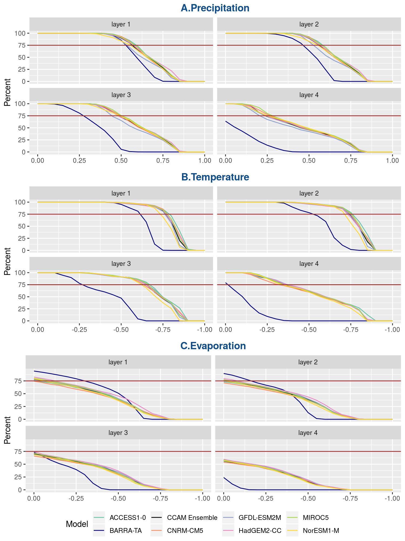

Figure 5 *The percentage of grid cells (on y-axis) greater than each correlation value. CCAM-ensemble members are coloured lines, with the CCAM-ensemble mean in black. BARRA-TA is represented as the dark-blue line. The red vertical line marks the 75% of all grid-cells threshold. A-C) shows the correlation between soil moisture and A) precipitation; B) temperature; C) evaporation.*

**Method**

we extracted the monthly time-series for soil moisture, precipitation, surface temperature and evaporation for each grid cell from each of RCMs and from BARRA-TA, and we explored the correlation between the range of variables using least squares regression provided by Schulzweida et al. (2006). The correlation values are the mean from individual correlation from each member of the ensemble. We selected the periods 1990-2019 and 2007-2014 in CCAM and in BARRA-TA, respectively.

To compare the soil moisture in CCAM and BARRA-TA, we took the mean of CCAM ensemble. Each grid cell from BARRA-TA and CCAM-ensemble had an eight-year monthly dataset from 2007 to 2014, and a multi-year monthly mean. We used the correlation equation least squares regression provided in *Climate Data Operators* (Schulzweida et al. 2006) to calculate the mean value between BARRA-TA and CCAM-ensemble. Then we did the statistics of spatial correlation and split the correlation into higher correlation area and low correlation area based on a critical point, which is described in detail below.

In order to calculate the statistics of the spatial correlation, we checked the distribution of correlation values over all grid cells. For this, we chose 21 correlation values between soil moisture and precipitation from 0 to 1 with a 0.05 interval (from -1 to 0 for the negative relationship between soil moisture and other two related variables: temperature and evaporation). We calculated the percentage of grid cells above each correlation value, as well as the average percentage of CCAM-ensemble. Last, we mark the 75% percentage line to better explain the change of curve between models.

**Outcome**

We investigated the spatial correlation between soil moisture and three related variables: precipitation, surface temperature and potential evaporation in CCAM-ensemble and compare them with similar metrics from BARRA-TA.

Similar to the correlation of soil moisture between CCAM-ensemble and BARRA-TA, higher correlation values were observed mainly in west Tasmania (Figure 4). Due to the negative relationship between soil moisture and two related variables: surface temperature and potential evaporation – the soil loses moisture with increasing surface temperature and hence increasing potential evaporation – a strong correlation between these variables is indicated by the most negative correlation values (-1). In the spatial distribution, grid cells with high correlations (above 0.5 or below -0.5) were located mostly in western Tasmania, while grid cells with low correlation values (below 0.5 or above -0.5) were located mostly in eastern Tasmania (Figure 4).

In the CCAM-ensemble, the first three layers showed similar pattern of correlation, but lower correlations in bottom layer 4 in all related variables. In BARRA-TA, the lower-correlation grid cells were located predominantly in the eastern Tasmania in the top three layers, and in particular in layer 3. In the fourth layer however, negative-correlation grid cells were distributed all over the study region, with the lowest values predominantly in the east part of Tasmania.

Here is the statistics of the spatial pattern of these correlations.

For the correlation with precipitation and temperature, CCAM-ensemble had better result of spatial distribution, where the correlation value is higher with 75% percentage than BARRA-TA (Figure 5-A and 5-B). In contrast, BARRA-TA had more grid cells with higher correlation with evaporation of around 75 % than CCAM-ensemble in the first two layers (Figure 5-C).

For the soil layers from surface to bottom, the high correlation (or anticorrelation) area decreased with depth in both CCAM-ensemble and BARRA-TA. There is difference between top layers and bottom layers and also between CCAM-ensemble and BARRA-TA.

**Discussion**

Our results indicate that CCAM-ensemble has higher correlations of soil moisture with precipitation and temperature than BARRA-TA, and higher correlation of soil moisture and evaporation in the first two layers. Best et al. (2011) points to multiple factors influencing surface evaporation, like evapotranspiration and bare soil evaporation. Plant root extraction for evapotranspiration can be another way to transport soil moisture into the atmosphere (Kowalczyk et al. 2006). Similarly, precipitation and surface temperature have a more complicated relationship with soil moisture than linear correlation. Our results could suggest that precipitation and surface temperature have a higher weight in adjusting the soil moisture in CCAM-ensemble than in BARRA-TA, and evaporation has a higher weight to this purpose in BARRA-TA than the CCAM-ensemble.

Our results showed that the top two layers in both CCAM-ensemble and BARRA-TA have a better representation of the relationship between soil moisture and the variables we investigated than the bottom layers. As shown in Figure 2 and 3, a larger time lag exists in BARRA-TA but only slightly larger in CCAM-ensemble, which could cause lower correlation values in the bottom layers between CCAM-ensemble and BARRA-TA. The correlation values of soil moisture between CCAM-ensemble and BARRA-TA are higher in the west and north Tasmania. In our study we found that the area of high correlation decreases with depth in CCAM-ensemble and BARRA-TA, and much faster in the latter. The different performance through layers, region and between two models could be caused by the different performance of layer, region within soil between CCAM and BARRA-TA, discussed in the following section.

**Comment**

Based on soil moisture, these two figures said there are different correlation between soil moisture and related variable over different region. But it just a beginning to show the different distribution of correlation over all domain.

Also, it shows that soil moisture has different weight with three related variables. Maybe this is the key point here.

**Figure 6**

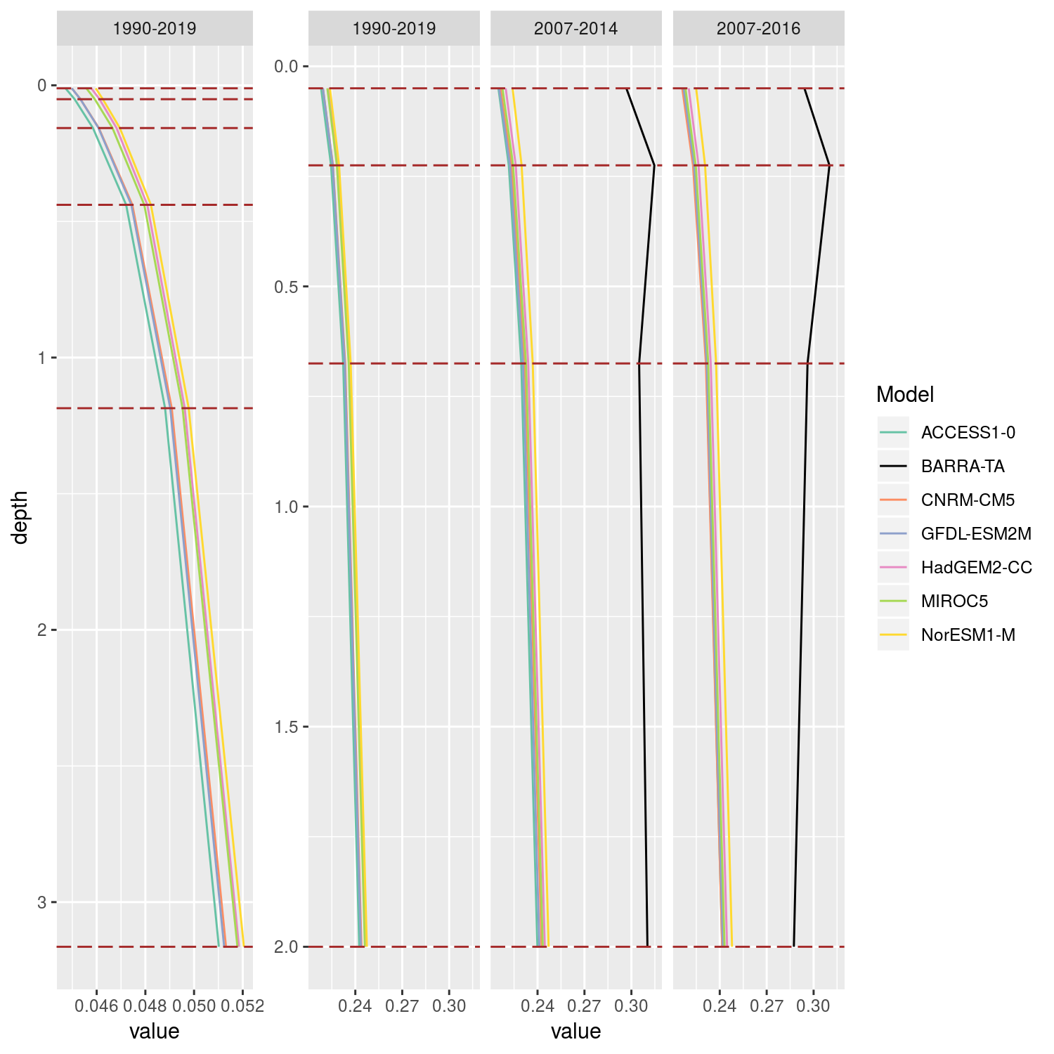

Figure 6 *Soil profiles of CCAM-ensemble and BARRA-TA in different time periods: a) the six-layers soil profile of CCAM-ensemble from 1990 to 2019; b-d) four-layer soil profile of CCAM-ensemble and BARRA-TA from: b) 1990 to 2019; c) 2007 to 2016; and d) 2007 to 2014. The soil profiles are derived from six (a) or four (in b, c, d) data points at the middle of each soil layer. Soil layer boundaries are represented by the brown long dash line. The data points for each layer is the mean value calculated from models throughout the corrected map range and the whole periodnnnn.*

**Method**

To allow comparison between BARRA and CCAM, we converted the six soil layers in CCAM into four soil layers matching the soil layers in BARRA (Table 3). Soil moisture is measured in cubic meter per cubic meter (m3/m3), and is considered homogeneous vertically within the same soil layer (Best et al. 2011; Kowalczyk et al. 2006), which can be presented in both CCAM and BARRA-TA. In order to define the new four soil layers in CCAM, we calculated the weighted sum of soil moisture from CCAM’s original six layers relative into the four new layers (Table 3).

The soil profiles are derived from six (a) or four (in b, c, d) data points at the middle of each soil layer. Soil layer boundaries are represented by the brown long dash line. The data points for each layer is the mean value calculated from models throughout the corrected map range and the whole period.

**Outcome**

The data points for each layer represent the spatial mean value of BARRA-TA and CCAM-ensemble throughout the standardized map range and the whole period. The profile of the six soil layers in CCAM-ensemble show that the soil moisture increased with depth (Figure 6a). In BARRA-TA, the first three layers were consistent throughout the two time periods (2007-2016 and 2007-2014), with the fourth layer being slightly different between the two periods.

For the CCAM-ensemble, soil moisture increased with depth showing the steepest change between the first and the second layer. In BARRA-TA, soil moisture reached its maximum in the second layer, and then decreased with depth. This suggests that the top two layers of BARRA-TA and CCAM-ensemble have a higher similarity, while the bottom two layers is relatively very different.

**Discussion**

The mean value in the first two top layers increased with depth for both CCAM-ensemble and BARRA-TA. For the bottom two layers, the soil profile decreased in BARRA-TA but continued to increase in CCAM-ensemble (Figure 6).

**Comment**

Why take soil profile?

Is there has strong evidence to present the difference of soil layers by soil profile?

**Figure 7**

**Analysis**

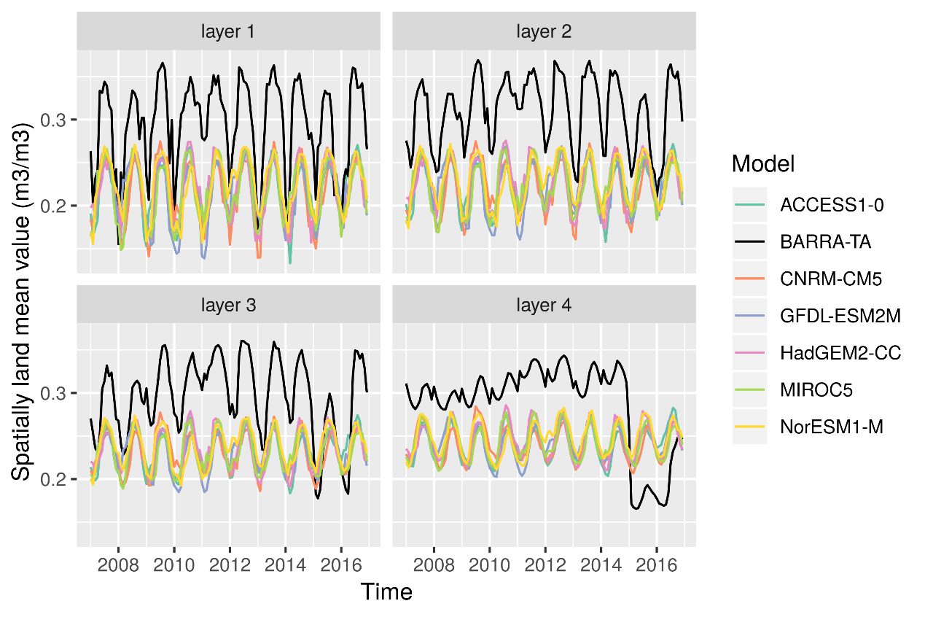

Figure 7 *Monthly time-series of soil moisture in BARRA-TA (in black) and CCAM-ensemble (in colour) between 2007-2016. The data is derived from the monthly mean across the entire region of Tasmania.*

**Methods**

**Outcome**

Figure 7 shows ten years (2007-2016) of monthly time-series of soil moisture in BARRA-TA and CCAM-ensemble. The value is calculated from the mean monthly value across the entire region of Tasmania. In the top two layers, the time-series values were higher in BARRA-TA than in CCAM-ensemble and showed a similar interannual cycle between the two models. In the bottom two layers, the ten-year time-series differed between the two periods (2007-2014 and 2015-2016) of BARRA-TA, with soil moisture values in the first period consistently higher than in CCAM-ensemble. The third soil layer showed a similar interannual cycle in its moisture content, while the fourth layer had a more varied value, with little evidence of an interannual cycle. In the second period of BARRA-TA, the third- and fourth-layer soil moisture values were mostly lower than in CCAM-ensemble. This suggests that these steep changes occur at the transition from JULES to ACCESS-G in BARRA-TA, which are related to the different methods of simulating the land-surface environment between the two time periods. In our evaluation of CCAM-ensemble, we used only the JULES model offline simulation data from 2007 to 2014, with focus on the top two soil layers.

**Discussion**

In 2015/2016, , the base model for regional reanalysis in BARRA was changed from UM to ACCESS-G and the land surface model was changed from JULES to MOSES 2 (Best et al. 2011; Su 2018). The latter model takes different methods to handle the land surface environment (Best et al. 2011; BoM 2010), with more focus on the atmospheric study and increased impact on the absorption of soil moisture around the plant root zone. For the study of soil moisture, we chose to use the JULES operation period in order to provide consistent assessment of CCAM-ensemble, that is, the period 2007-2014.

We found soil moisture in BARRA-TA was typically higher than in the CCAM-ensemble. Previous studies showed that this could arise from the method used to model the hydrological processes. For example, in JULES, there are two pathways for the water once it reaches the soil surface: infiltration into the soil and surface runoff (Best et al. 2011). In BARRA, JULES has runoff switched off, as the river routing is not included for the limit-area model (Su 2018). In CCAM, CABLE takes surface runoff as one of the dominant factors for the flux of infiltration (Kowalczyk et al. 2006). The large source of water into the soil in BARRA-TA may cause these higher values than CCAM. This study focused on the general trends, rather than the absolute soil moisture values.

**Comment**

In the result, there should point out the difference between two period.

**Figure 8**

**Analysis**

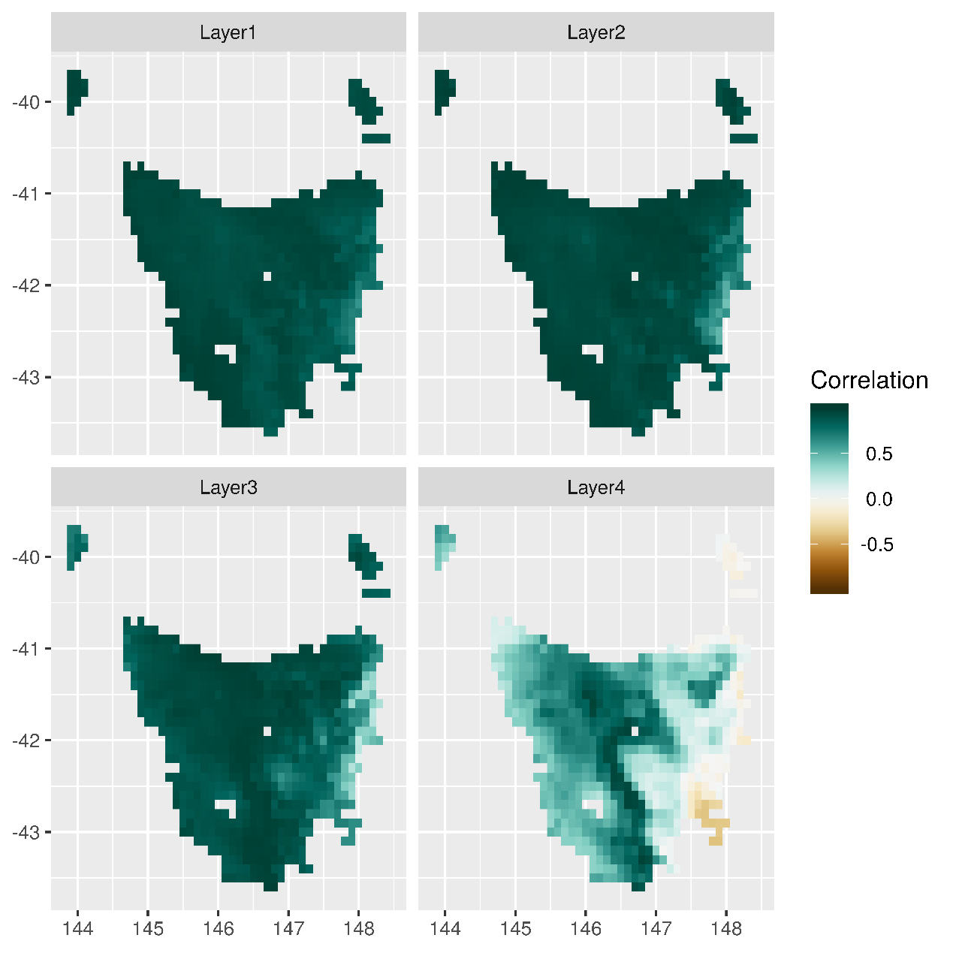

Figure 8 *The correlation of monthly annual cycle between soil moisture in CCAM-ensemble and BARRA-TA calculated from the multi-year monthly mean values over all grid cells in Tasmania. Here, the resolution of CCAM-ensemble and BARRA-TA is 10km.*

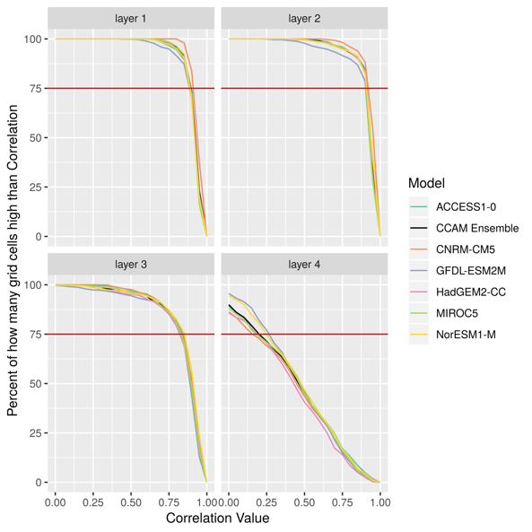

Figure 9 *the percentage of grid cells (y-axis) with correlation values higher than the critical point (x-axis) over all model grid cells for CCAM-ensemble (in colour). The CCAM-ensemble mean value is shown in black for reference.*

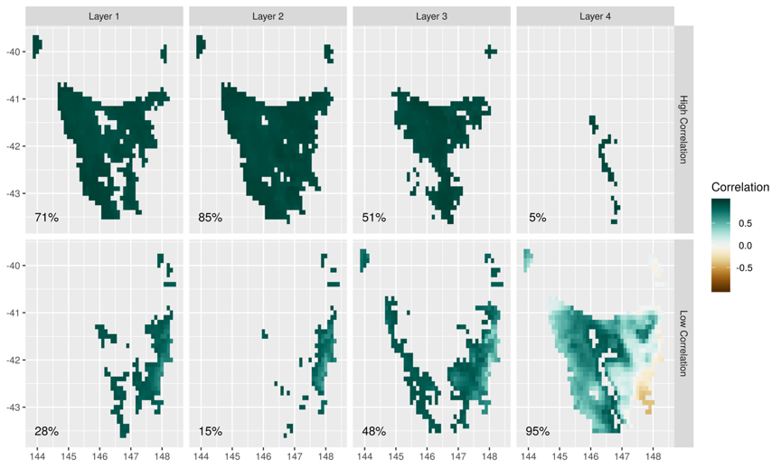

Figure 10 *Partition of the correlation map by the correlation critical point 0.90. The top (bottom) row shows grid cells with higher (lower) correlation values than the critical correlation point (0.90) from layer 1 to layer 4.*

**Methods**

For visualizing the spatial distribution within soil moisture between CCAM-ensemble and BARRA-TA, we split each correlation map into two parts: high-confidence areas and low-confidence area based on the critical point.

In choosing the critical point, we decided to:

1. Take the CCAM-ensemble mean.
2. Consider the first surface soil layer as the standard, because the distribution of the correlation values among the four layers was not consistent. This was justified because the first surface soil layer provides the platform for direct interaction between precipitation, surface temperature, evaporation and soil moisture and it can avoid the contribution of differing hydrological models;
3. Choose the critical correlation point which was the closest to 75% percentage in the first layer in the CCAM-ensemble.

**Outcome**

There is the correlation of soil moisture between CCAM-ensemble and BARRA-TA over the entire region of Tasmania. The multi-year monthly mean values showed higher correlation in most grid cells in the first three layers (Figure 8), which could reflect a strong interannual cycle in the CCAM-ensemble. The first two soil layers showed a similar pattern where the correlation values are higher than 0.9 over more than 71% grid cells (Figure 10). The third soil layer was less well correlated, with the lowest correlation in the fourth soil layer, particularly in the southeast corner (where the correlation was also negative) (Figure 10). This correlation decreased towards the east, the lowest value being observed on the east coast of Tasmania. In the fourth layer however, there was a high correlation from inland western Tasmania towards central Tasmania. Very high correlation values were observed in the first three soil layers (Figure 9), with the percentage of grid cells with high correlation rapidly decreasing once below 0.85. In the fourth layer the situation is different. The percentage of grid cells with high correlation decreased consistently.

**Discussion**

In the spatial correlation of soil moisture between CCAM-ensemble and BARRA-TA, we found the correlation values of soil moisture are higher in the west and north of Tasmania. The topography of south-east Tasmania is mostly lowland, resulting in mostly dry area with lower annual precipitation than the north and west mountainous region (Grose et al. 2010; White et al. 2013). In dry areas, the change of soil moisture is more closely related to episodic precipitation. But in wet areas, soil moisture will dry out or filtrate slowly over time, which can be easier to simulate in both models. Hence in dry areas, the timing of simulated precipitation is crucial for an accurate modelled output of soil moisture.

Technically, the characteristics of soil could be represented by the soil type (Koster et al. 2009). Soil type in BARRA-TA has various change spatially, but is more consistent in the east region than soil type in CCAM (Figure 1). CCAM has only two separate soil types, and has uneven distribution in the east region. Therefore, soil type in BARRA-TA could be more realistic to represent the characteristics of soil. The soil types in BARRA-TA and CCAM are composed of multiple parameters (Table 2), they are constant in time and do not change with precipitation, which can be a limitation, especially for applications on a small spatial scale over a long period of time (Corney et al. 2010).

**Comment**

Seems not serious enough. Is there any evidence?

**Figure 11**

**Analysis**

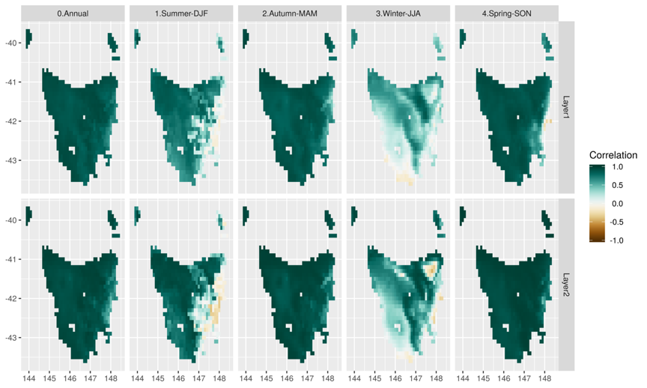

Figure 11 *The correlation of daily seasonal and annual time-series between soil moisture in CCAM-ensemble and BARRA-TA calculated from the multi-year daily mean values over all grid cells in Tasmania. Here, the resolution of CCAM-ensemble and BARRA-TA is 10km.*

**Method**

For calculating the seasonal variation, we used the daily soil moisture in layer 1 and 2 for four calendar seasons in 1990-2019 for CCAM-ensemble and 2007-2014 for BARRA-TA. We calculated the seasonal mean at each grid cell for the CCAM-ensemble members.

For the same range of years, we explored the correlation of season variation in layer 1 and layer 2, by calculating the multi-year daily mean values for each season and each grid cell. We calculated correlation values from BARRA-TA and each CCAM-ensemble member by least squares regression, and then calculated the CCAM-ensemble mean.

**Outcome**

For the seasonal variation, different seasons has different distribution of spatial correlation. In summer, there are more low correlation grid cells in the east region. In Winter, there are more low correlation grid cells in the west and south region, and also the east coastline. The grid cells with high correlation in winter are mostly distributed in the middle and north Tasmania. In autumn and spring, the grid cells with high correlation takes most region but not the east coastline. Overall, the eastern region had a higher number of grid cells with low correlation of seasonal variation in layer 1 and 2 between CCAM-ensemble and BARRA-TA (Figure 11). More extensive areas of low correlation were observed in summer and winter, with the winter low correlation area extending over almost the entire region.

**Discussion**

This study shows a lower correlation between CCAM-ensemble and BARRA-TA over most grid cells in winter compared to the other three seasons. Also, low correlation was observed in the east region in summer, and to a smaller degree in autumn and spring. The grid cells with lower correlation are mostly dry in summer. The difference in seasonal maximums across the four seasons in the CCAM-ensemble and BARRA-TA could cause the lower values observed in the winter.

**Comment**

Not enough to explain the seasonal change of soil moisture

What we got now is only the correlation between BARRA and CCAM for the seasonal dataset

How about the seasonal time series? The seasonal value of soil moisture shown in the map?

**Figure 12**

**Analysis**

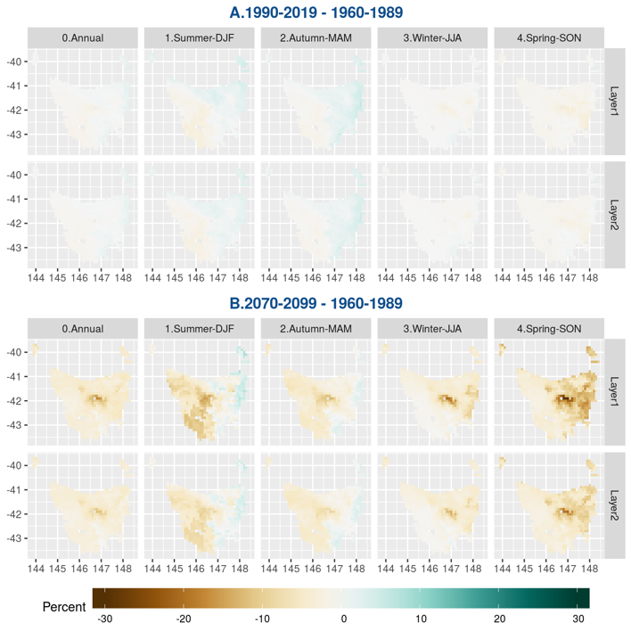

Figure 12 *Percentage of change in soil moisture in CCAM-ensemble between three periods: historical (1960-1989), current (1990-2019) and future (2070-2099) and for each season. Columns from one to five correspond to the change in annual, autumn, spring, summer and winter.*

**Method**

We explored the projected values of soil moisture for three time periods: historical (1960-1989), current (1990-2019) and future (2070-2099). We calculated the mean value for each grid cell. We found that RCMs were very similar, therefore we considered the mean of the CCAM-ensemble. We compared the variation of soil moisture in the top two soil layers across 30 years, between historic and current period and between historic and future period. To analyse the seasonal change in soil moisture, we considered four calendar seasons (MAM, SON, DJF, JJA) and compared its variation in the future from historical and current period.

**Outcome**

There has been minimal change between the historical and current periods, where the change is within 5%. In exploration of future projections from the CCAM-ensemble, the general trend indicates that the soil moisture will decrease in the region of Tasmania in the future, with the driest area being projected to be around the central plateau. The east region will get wetter in summer and autumn in the future (Figure 12-B). This wetter area had low correlation of soil moisture between BARRA-TA and CCAM-ensemble (Figure 11). Soil moisture will be lower in all the study region in winter and spring and with less change in the west Tasmania in winter. In regards with the current change (Figure 12-A), the wetter region in the east region is expected to decrease in the future, while the drier region is expected to increase.

**Discussion**

Model predictions show that wetter area could decrease in the future in the east region of Tasmania, while the drier area could increase. This could be caused by the rise of temperature in Tasmania, while the drier area could increase.

Focusing on the surface layers, which we have more confidence in than the lower layers for the reasons discussed above, shows that the future changes between layer 1 and layer 2 have the same pattern in CCAM-ensemble. Soil moisture in layer 1 has larger change than in layer 2, which could be caused by direct effect with related variables in surface layer 1.

Spatially, the drier area with large magnitude (more than 10% approximately) has higher correlation compared with BARRA-TA than the wetter or slight-changed area in the future. In summer, the correlation between CCAM-ensemble and BARRA-TA shows there are high correlation in the west region in the future change. The west region will become drier than the east region, where the soil moisture will increase or change slightly in the future. In winter, the correlation between CCAM-ensemble and BARRA-TA shows there are lower correlation in the southwest region. In future change, this region is no obvious change or change slightly.

Supported by BARRA-TA, CCAM can be confident to project the future change in the region, where the soil moisture will decrease rapidly (approximately more than 10 %)

**Comment**

The future change is based on the seasonal change. As the seasonal change has not been explained enough, the future change is suspicious.